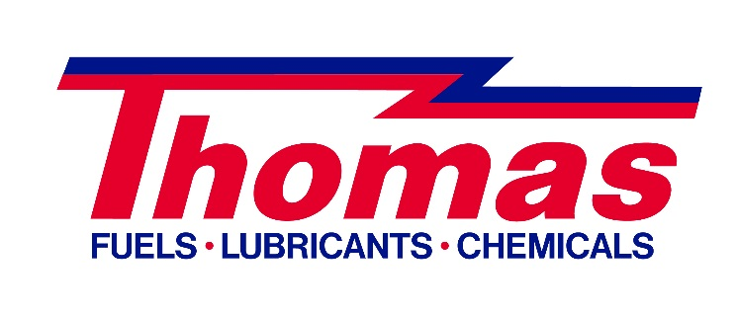
A Pilot Thomas Logistics company

February 27, 2015

Thank you for choosing Thomas Petroleum as your cardlock fuel provider. We are excited with the opportunity to meet your fleet fueling needs.

The Thomas Petroleum fleet fueling program will provide you with:
- Savings – Save time and money
- Security – Experience the highest level of protection
- Control – Manage every aspect of your fueling process
- Convenience – Enjoy the best products and services available
Embedded below are 3 documents. The first is a Card Request Form. Please complete this form electronically and return to us No later than March 13th, 2015. The next document describes the Features and Benefits of the Thomas Petroleum fleet fueling program. Lastly, attached is the list of fuel sites available to the State of Nevada through the Thomas Petroleum fleet fueling card.

Our goal at Thomas Petroleum is to assist you in operating as efficiently as possible. We know this can be done by providing you with the best products and services available.

Please contact our Customer Service department at 800.777.9251 should you have any questions.

Sincerely,

Paul Anderson
Account Manager

